1.FLOWCHART FOR FIBONACCI SERIES UP TO GIVEN NUMBER THROUGH RAPTOR

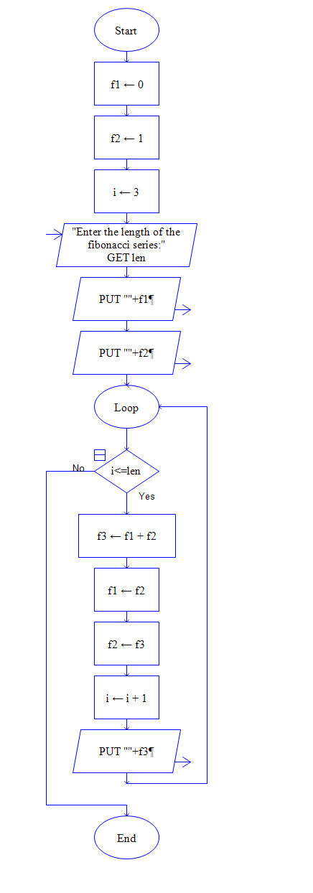

2. FIND THE LARGEST OF THREE NUMBERS

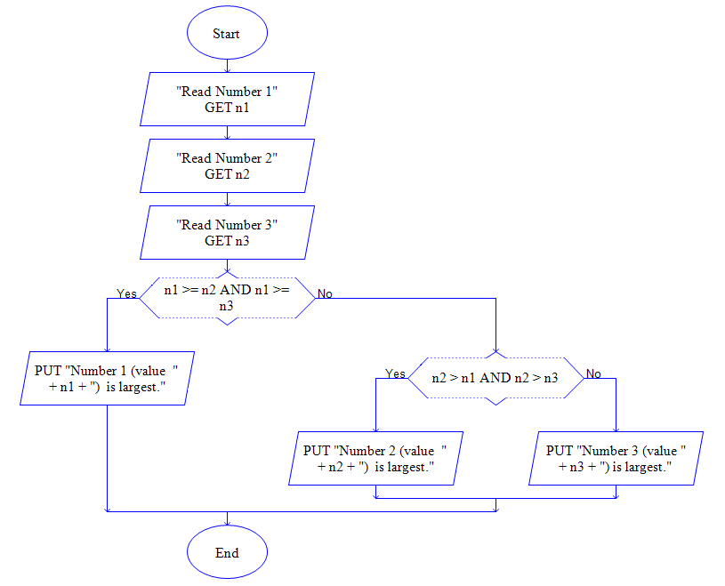

3.FLOWCHART TO PRINT ALL THE NUMBERS UPTO GIVEN NUMBER

